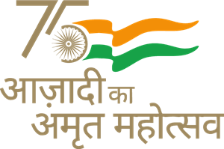  दक्षिण रेलवे SOUTHERN RAILWAY
Name of the Officer / Designation | Office of the DRM/O/MDU
Name of the Officer / Designation | Date:

आपातकालीन कोटा के लिए आवेदन
(रेलवे अधिकारियों द्वारा अनुशंसित)
APPLICATION FOR EMERGENCY QUOTA
(RECOMMENDED BY RAILWAY OFFICIALS)

Train No.
Date of Journey
From - To
Class
No. of Berths / seat
PNR No
Name of the Passenger
Address
Ph.No. / Cell No.
Special Reason
I certify that I am fully aware of the entitlement regarding allotment of accommodation through Emergency Quota and I certify the eligibility and attest the Identity of the passengers for allotment of accommodation from Emergency Quota. I, hereby, undertake full responsibility of passenger’s credentials for whom I am recommending for allotment of berth(s)

Particulars of Railway Officials:

Name :
Designation :
Office :
Phone No. : Signature

